Preparing your heart for Easter
Praying New Life Scripture

Isaiah 57:10
You were wearied with the length of your way, but you did not say, “It is hopeless”; you found new life for your strength, and so you were not faint.
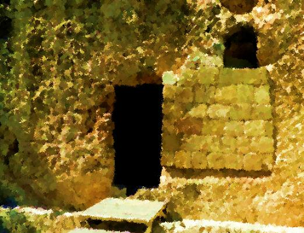
Father, there are moments when I am weary with challenges. Then I am tempted to say circumstances in my life are hopeless, but I know you have authority over all things, even life and death. Help me to overcome my weakness by your strength, to find refreshment for life that will help me not to be faint. Nothing is hopeless when I trust in you, my risen and redeeming Lord.
In the name of the one whose life gives hope,
Amen

Ezekiel 36:26
And I will give you a new heart, and a new spirit I will put within you. And I will remove the heart of stone from your flesh and give you a heart of flesh.
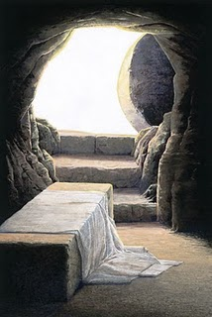
Lord of my heart, I praise you for seeing my stone heart and for taking it away, giving me a new heart in its place. You intended good for me, though I was hard and far from you. Thank you for the gift of your Spirit and your presence within me. Help me to bear Spirit fruit that grows from the new heart you’ve put in me.
In the name of the One
who changed my heart,
Amen
Romans 6:4
We were buried therefore
with him by baptism into death, in order that, just as Christ was raised from the dead by the glory of the Father, we too might walk in newness of life.

Lord,
I want to walk each day in newness of life, instead of in my old ways that were buried with you and declared dead. Like you raised your Son to be alive, raised me today and every day to behave and act and live with your power obviously at work in me.
Amen

1 Corinthians 15:50-52

I tell you this, brothers: flesh and blood cannot inherit the kingdom of God, nor does the perishable inherit the imperishable. Behold! I tell you a mystery. We shall not all sleep, but we shall all be changed, in a moment, in the twinkling of an eye, at the last trumpet. For the trumpet will sound, and the dead will be raised imperishable, and we shall be changed.
Lord of life, there is no doubt life & death remain a mystery to me. You’ve promised life goes beyond this world, that those who belong to you will be raised, and you will change us. I praise you as the God of the imperishable, with power over death & the lover of life.
Amen
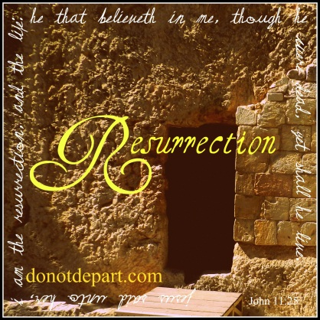
Philippians 2:5-8
Have this mind among yourselves, which is yours in Christ Jesus, who, though he was in the form of God, did not count equality with God a thing to be grasped, but emptied himself, by taking the form of a servant, being born in the likeness of men. And being found in human form, he humbled himself by becoming obedient to the point of death, even death on a cross.

God of life, I am not naturally humble or a servant or obedient. I’m so unlike Christ Jesus who emptied himself into human form. I praise you for obedience to the point of death on a cross, so I can live spiritually and eternally. Would you teach me to think thoughts like Jesus and have his attitude, so you will be glorified and others will find life in you?
In the name of the servant Jesus,
Amen

1 Thessalonians 4:15-17
For this we declare to you by a word from the Lord, that we who are alive, who are left until the coming of the Lord, will not precede those who have fallen asleep. For the Lord himself will descend from heaven with a cry of command, with the voice of an archangel, and with the sound of the trumpet of God. And the dead in Christ will rise first. Then we who are alive, who are left, will be caught up together with them in the clouds to meet the Lord in the air, and so we will always be with the Lord.
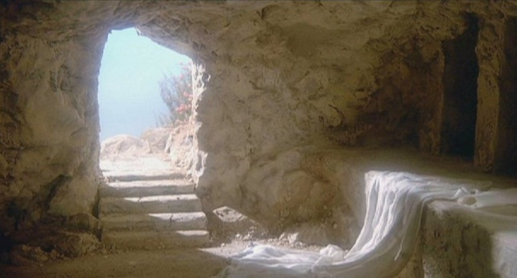
God of the resurrection,
just as your Son was raised one morning from a stone enclosed tomb, someday you will raise those who have known you and passed from this life. Others of us will meet you in the sky full of clouds. I’m thankful to be spiritually alive now, but to know that everlasting life with you awaits. Since Jesus defeated death, I will always be with you.
Amen

